**Event-Based Control**

**Rui Carapinha 248728**

**First Task – One Car**

The first task was to control a single car, with a traffic light and a tunnel. The car can only enter the tunnel when the traffic light is green.

To do this I made a simple SimuLink script. This script consists in two StateFlow graphs, one to control the lights and the other to control the car. The global graph is the following:

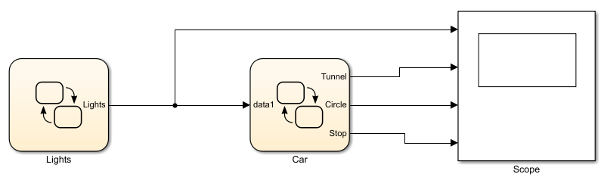

The first graph, Lights, is the following:

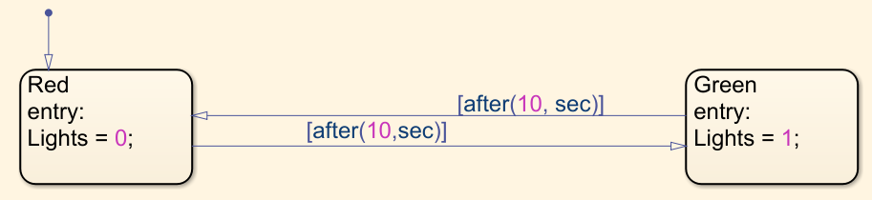

This graph changes the variable Lights every 10 seconds. When Lights is equal to 1 we have green light, when Lights is equal to 0 we have red light. This variable is an input to the Car graph.

The second graph, Car, is the following:

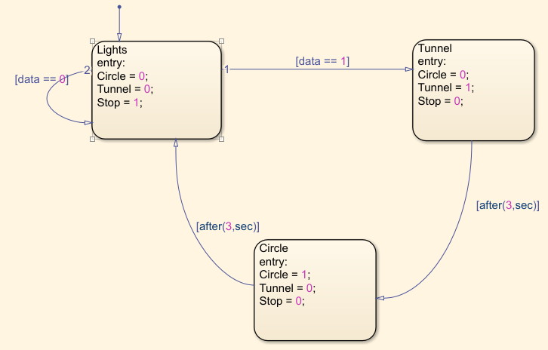

This graph starts with the car stopped and always checking the lights. When the lights turn green (data == 1), the car starts to run the tunnel and after 3 seconds it leaves the tunnel and starts doing the circle. After 3 more seconds, it reaches the light again and checks the light to see if it’s red or green.

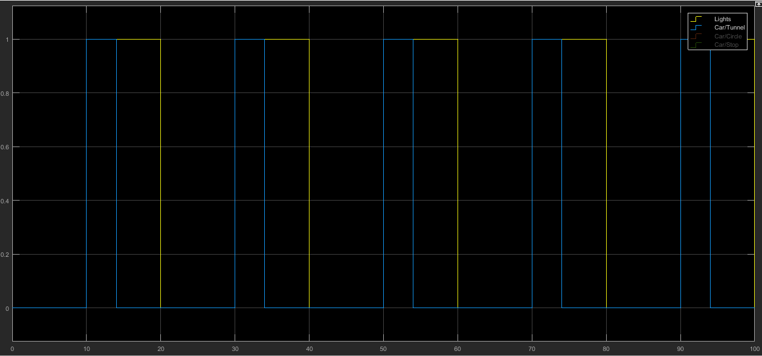The results I got were the following:

Figure 1 - Lights (Yellow) and Tunnel (Blue)

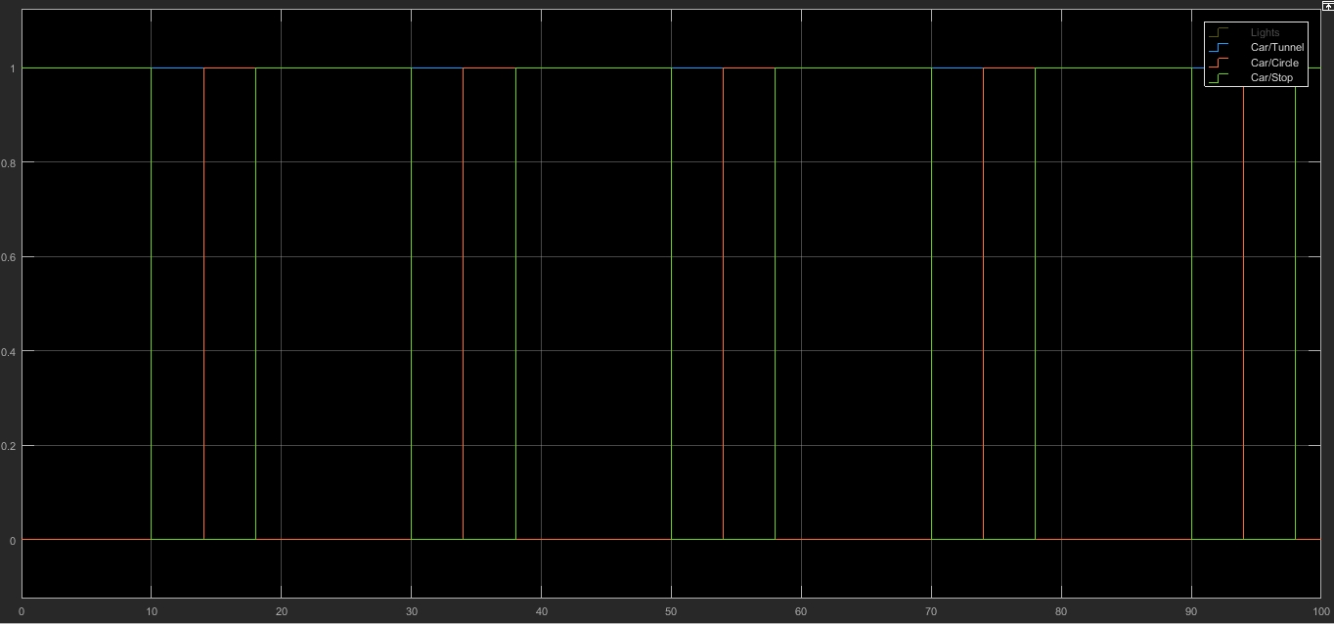Figure 2 - Tunnel (Blue), Circle (Orange), Stop (Green)

As we can see by the results, the problem was well solved and accomplished everything we needed.